GILBERDYKE HEALTH CENTRE- NEWSLETTER

DECEMBER 2018

**MCj02793500000[1]**

**The Doctors and the staff at the practice wish all our patients Happy Christmas &**

**Best Wishes for the New Year!**

**Christmas and New Year Opening Hours**

**Friday 21st December surgery closing at 6.30pm**

**Monday 24th December open from 8am to 6pm**

**Tuesday 25th December closed**

**Wednesday 26th December closed**

**Thursday 27th December open as usual**

**Friday 28th December open as usual**

**Monday 31st December open from 8am to 6pm**

**Tuesday 1st January closed**

**Wednesday 2nd January normal surgery opening hours**

**There is no need to order your prescription early or extra as we are only closed for 2 days and it creates a backlog if you order unnecessarily. If needed for Xmas, please order by Tuesday 18th December.**

FOR URGENT **MEDICAL ADVICE** PHONE **111**

FOR **MEDICAL EMERGENCIES** PHONE **999**

**Wi-Fi**

The practice now has Wi-Fi available in our waiting room, to access this choose NHS Wi-Fi and the information requested.

**GP Training**

Our GP’s continue to receive Hull & York Medical Scholl placements for students at Gilberdyke and would like to pass on our thanks for the support we receive from patients who agree for them to be included in the consultation.

**Staffing**

We welcome back Dr Yasmin Zaidy from maternity leave, her surgeries are on a Monday and Thursday.

Elaine our Health Visitor will now be based at Brough Surgery, we will miss having Elaine on site but will see her from time to time if she is doing any clinics at Gilberdyke.

**Flu Vaccines**

Thank you for all supporting our Flu Campaign and attending our Saturday morning clinics, we still have vaccine in stock so if you are eligible please book an appointment for your vaccination.

**Winter months**

Although we do our utmost to keep the surgery entrance clear please be aware that it may be slippery due to fallen leaves and ice, take extra care during the winter months on the paths.

**Improved Access Service**

**From 1 October 2018 our local federation, Yorkshire Health Partners won the bid to deliver this service.**

**You may have seen the poster below in our waiting room:**

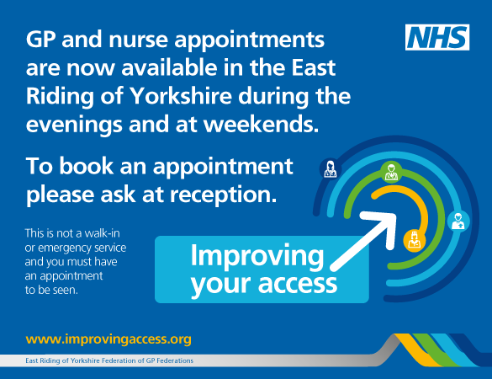

**How does the service work?**

Patients will be able to book appointments through their practice either by telephone or in person. All appointments are to be offered on an equal basis. These appointments are pre-bookable, with some on-the-day appointments also available. The appointments are for routine primary care – they are not out-of-hours, urgent care or minor injuries.

Patients may opt for an appointment which requires them to attend their consultation at another practice or location, and may be seen by someone who is not their regular doctor. They can be seen anywhere that is convenient for them – for example if a patient lives in Goole but works in Beverley, they may want an appointment in Beverley after work. In the new service arrangements, they will be able to have it.

The service is still in its initial stages and we are trying to resolve any issues that arise as quickly as possible.

More information on the service can be found at [www.improvingaccess.org](http://www.improvingaccess.org).

**If you have any queries regarding the practice please call us on 01430 440225**